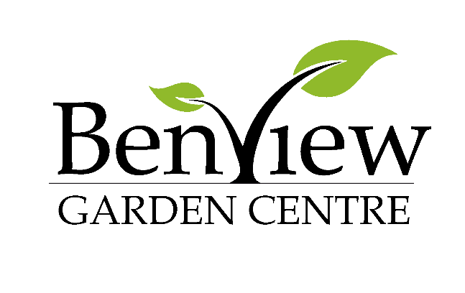

Levingtons Bark (60L) - £5.49 / 3 for £15
Levingtons with Added John Innes (50L) - £6.99 / 3 for 2 £13.98
Levingtons Essentials (40L) - £4.49 / 3 for £11
Miracle-Gro All Purpose (40L) - £4.99 / 3 for £14
Miracle-Gro Performance Organic AP (40L) - £6.49
Levington Original (40L) - £4.99 / 3 for £12
Miracle-Gro AP Peat Free (40L) - £5.49
Miracle-Gro Grow Your Own (50L) - £6.49
Levington Rose, Tree & Shrub (50L) - £5.99 / 3 for 2 £11.98
Miracle-Gro Moisture Control (40L) - £4.99 / 3 for £14
Levington Ericaceous (50L) - £6.99 / 3 for 2 £13.98
Levington Top Soil (35L) - £4.49 / 3 for £11
Levington Farmyard Manure (50L) - £4.99
Mushroom - £5.00

